8" Coaxial Ceiling Speaker (10W/20W/40w)
FCS-640C
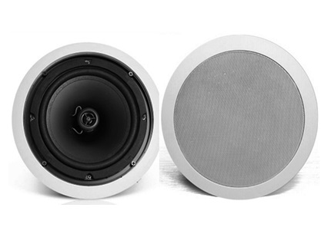
Feature:
- Commercial ceiling speaker with transformer
- Ideal for school, office, hotel and airport background music system
- Rated power output 10W/20W/40w at 100V
- 8" coaxial paper woofer and 1.5” tweeter
- Line input 100V or 70V
- ABS enclosure and metal grille in white
- Flush mount in-ceiling quick and secure installation

Specification：
Model | FCS-640C
Description | 8” Coaxial Ceiling Speaker
Rated Power Output | 10W/20W/40w
Line Input | 100V or 70V
Frequency Response | 50-18KHz
SPL(@1W/m) | 93dB
Speaker Unit | 8" coaxial paper woofer and 1.5” tweeter
Cutout Size | 248mm
Dimension | 280(D)×100(H)mm
Material | ABS enclosure and metal grille in white
Mounting Way | Flush mount in-ceiling quick and secure installation
Weight | 1.3kg

Dimension & Mounting Guidance:
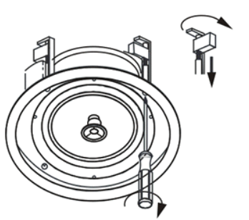
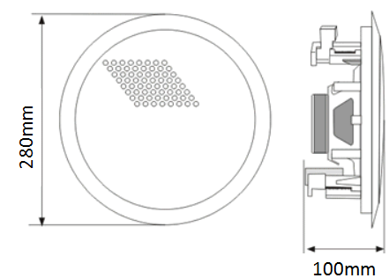

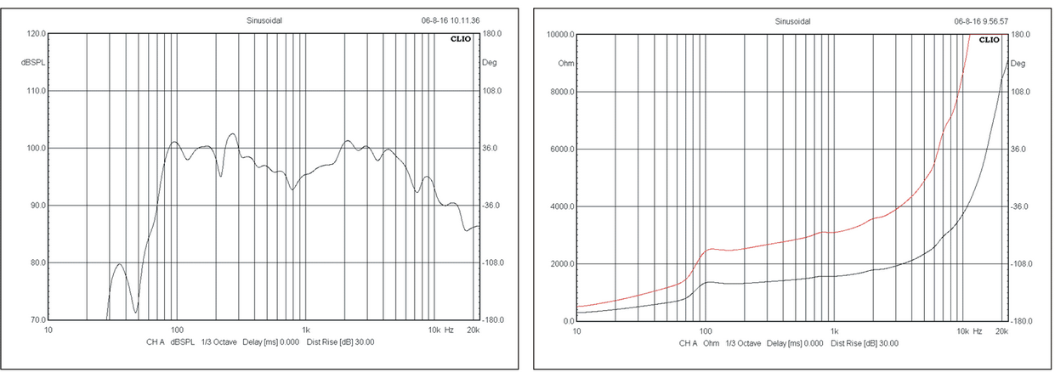
Frequency Response & SPL Diagrams：

